# **Mutable Objects & Functions Final Review**

# What’s the Point(er)? || Point(er) of Order

[Spring 2017 Final #2, Spring 2016 Final #2a, b]

# 

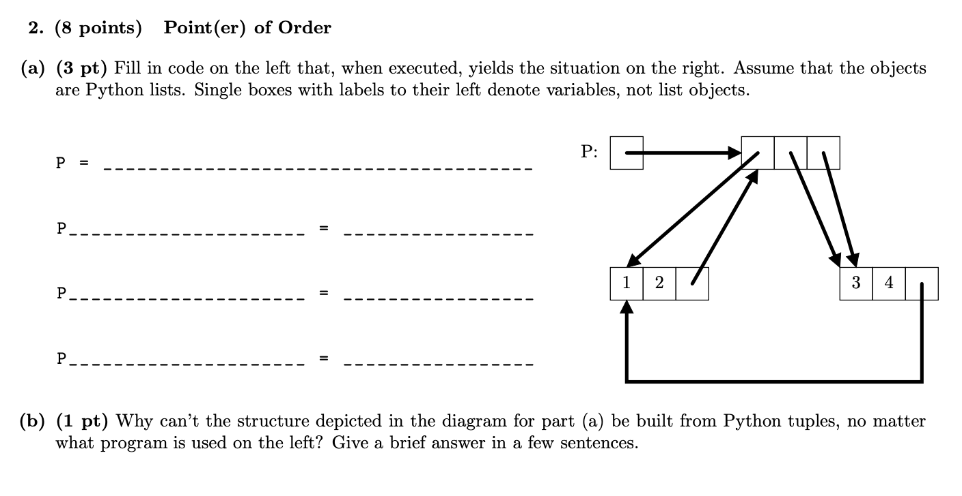

# Boxes and Arrows

[Fall 2016 Final #3]

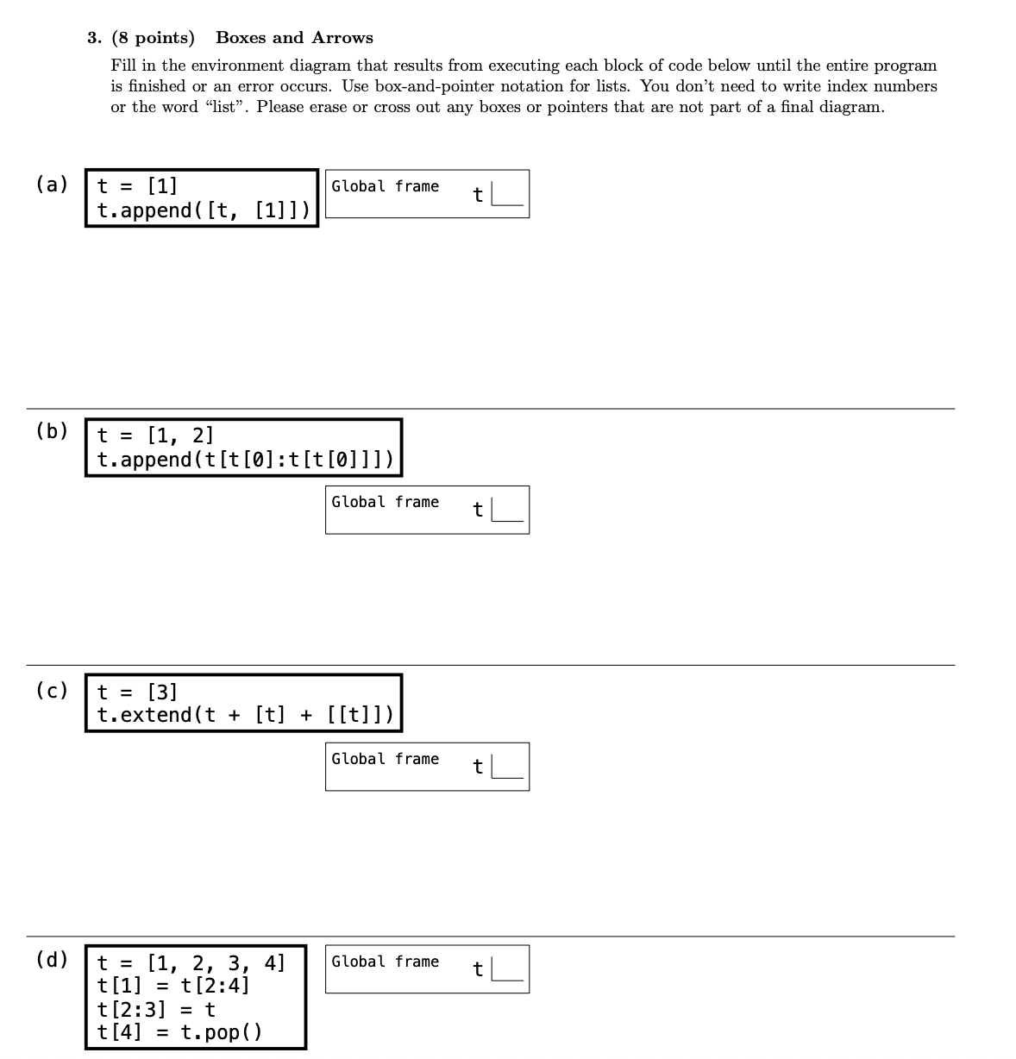

# 

# WWPD?

[Summer 2015 Final #2b]

# 

# 

# Return Policy

[Spring 2016 Midterm 2 #3]

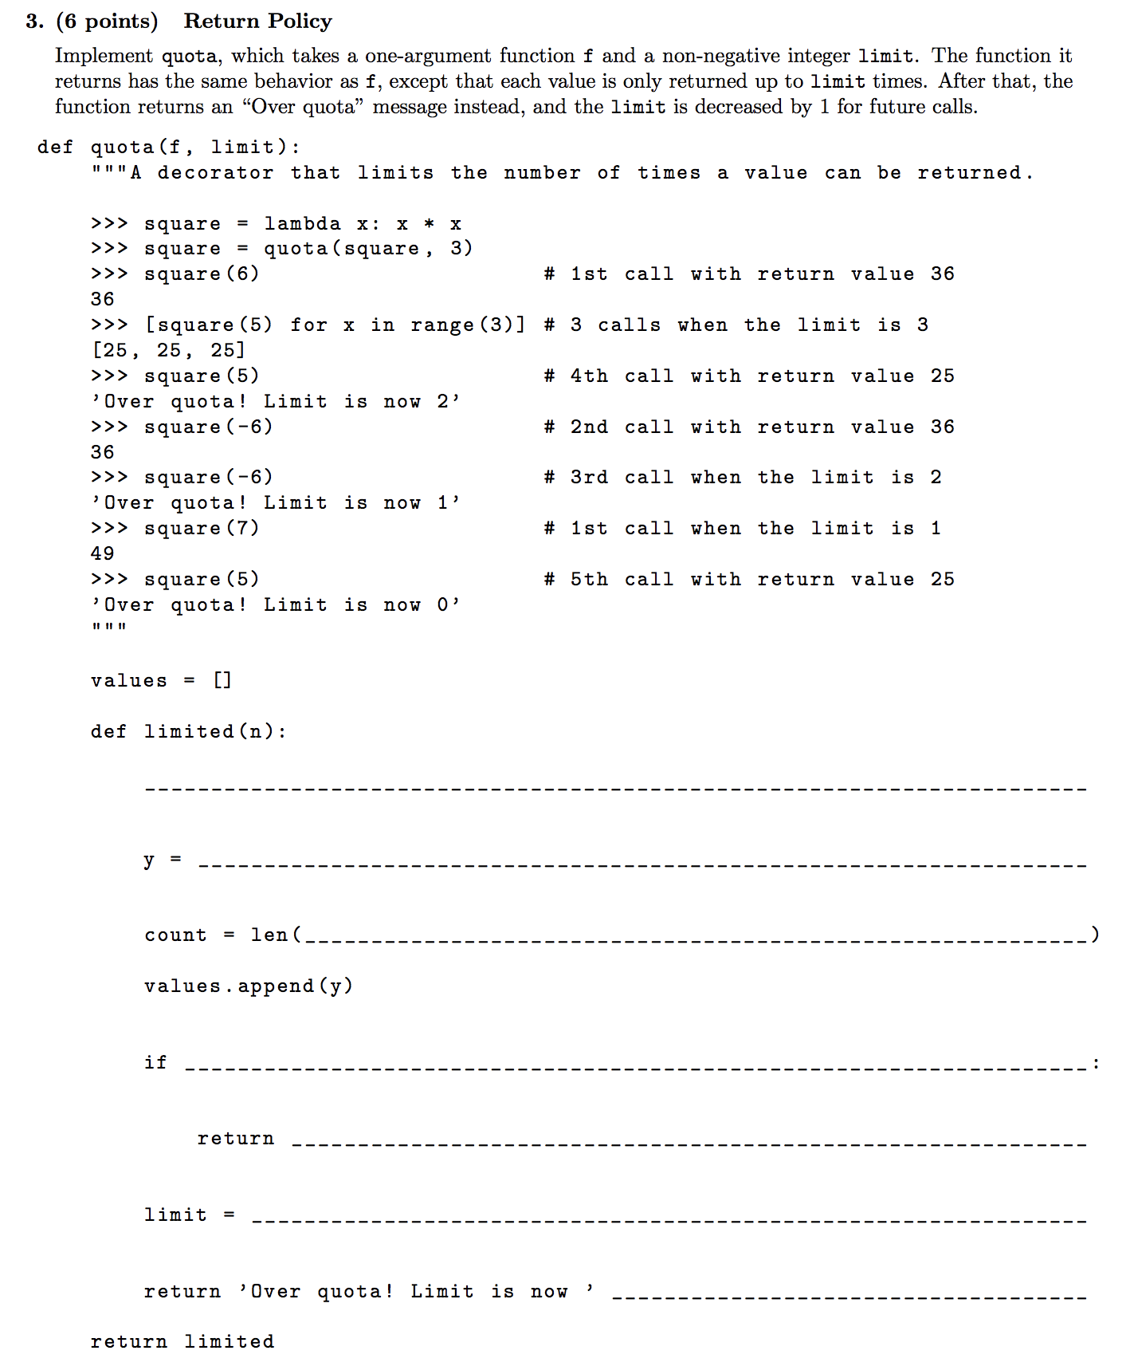

# Tree Paths

# [Spring 2017 Midterm 2 #3]

